# **MATPLOTLIB ASSIGNMENT:**

# Create a scatter plot using Matplotlib to visualize the relationship between two arrays, x and y for the given data. x = [1, 2, 3, 4, 5, 6, 7, 8, 9, 10] y = [2, 4, 5, 7, 6, 8, 9, 10, 12, 13].

1. import numpy as np
2. import pandas as pd
3. import matplotlib.pyplot as plt
4. plt.scatter(x,y,color ='r')
5. plt.title('relationship between x and y')
6. plt.xlabel('x')
7. plt.ylabel('y')
8. plt.show()

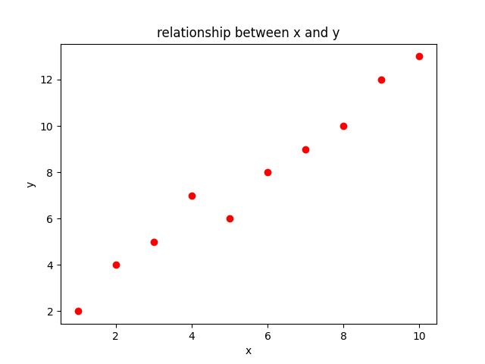

# 2. Generate a line plot to visualize the trend of values for the given data. data = np.array([3, 7, 9, 15, 22, 29, 35]).

import matplotlib.pyplot as plt

plt.plot(data)

plt.title('trend of value')

plt.xlabel('Index')

plt.ylabel('Value')

plt.show()

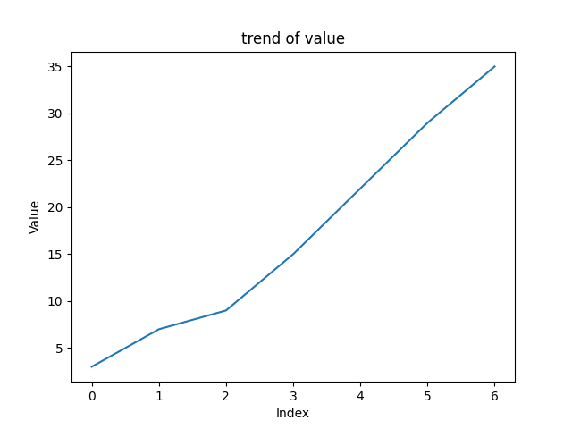

# 3. Display a bar chart to represent the frequency of each item in the given array categories. categories = ['A', 'B', 'C', 'D', 'E'] values = [25, 40, 30, 35, 20].

import matplotlib.pyplot as plt

plt.bar(categories,values,color='r',align='center')

plt.title('category wise value')

plt.xlabel('categoris')

plt.ylabel('values')

plt.show()

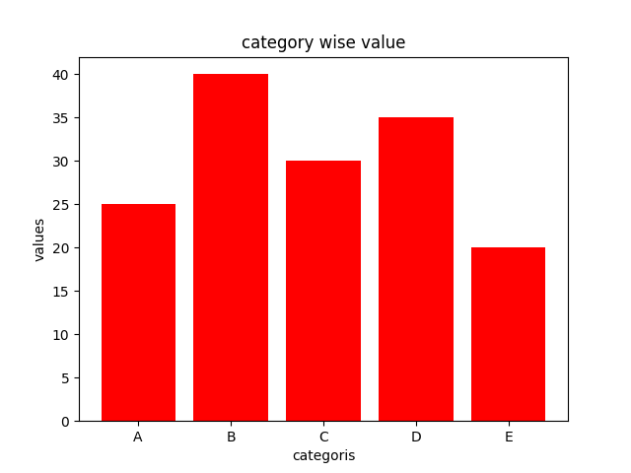

# 4. Create a histogram to visualize the distribution of values in the array data. data = np.random.normal(0, 1, 1000).

import matplotlib.pyplot as plt

import numpy as np

# Generate random data

data = np.random.normal(0, 1, 1000)

# Create the histogram

plt.hist(data, bins=30, color='blue')

# Add labels and a title

plt.xlabel('Value')

plt.ylabel('Frequency')

plt.title('Histogram of Random Data')

# Show the plot

plt.show()

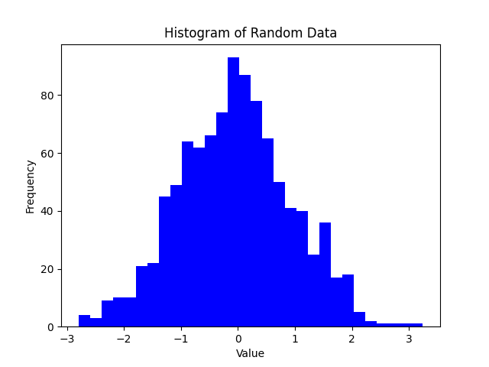

# 5. Show a pie chart to represent the percentage distribution of different sections in the array `sections`. sections = ['Section A', 'Section B', 'Section C', 'Section D']  sizes = [25, 30, 15, 30].

explode =[0.01,0.1,0.01,0.02]

plt.pie(sizes,labels=sections,autopct= '%1.1f%%',shadow=True,explode=explode,)

plt.show()

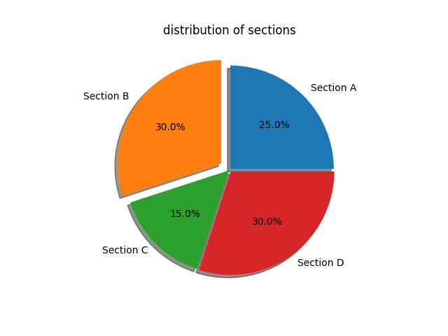

# **SEABORN ASSIGNMENT:**

# Create a scatter plot to visualize the relationship between two variables, by generating a synthetic dataset.

import seaborn as sns

sns.get_dataset_names()

health = sns.load_dataset('healthexp')

health.head()

sns.scatterplot(x=health['Year'], y=health['Life_Expectancy'],hue=health['Country'])

plt.title('Year wise Life Expectancy')

plt.show()

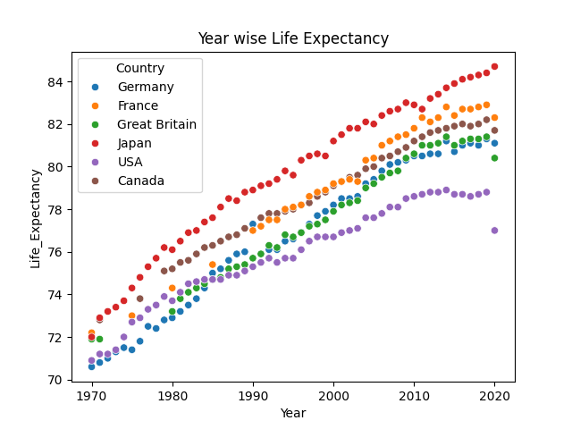

# Generate a dataset of random numbers. Visualize the distribution of a numerical variable.

import numpy as np

import seaborn as sns

import matplotlib.pyplot as plt

data = np.random.normal(1,100,1000)

sns.histplot(data, kde=True, bins=30)

plt.show()

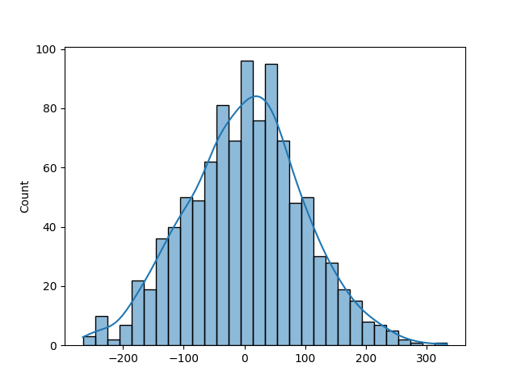

# 3. Create a dataset representing categories and their corresponding values. Compare different categories based on numerical values.

import pandas as pd

data ={

'categories' : ['Computer','Laptop','Mobile','Smartwatch'],

'Sales' : [45,93,100,123] }

data = pd.DataFrame(data)

data

sns.barplot(x=data['categories'],y=data['Sales'],color='y')

plt.title('Sales by categories')

plt.xlabel('Categories')

plt.ylabel('Sales Value')

plt.show()

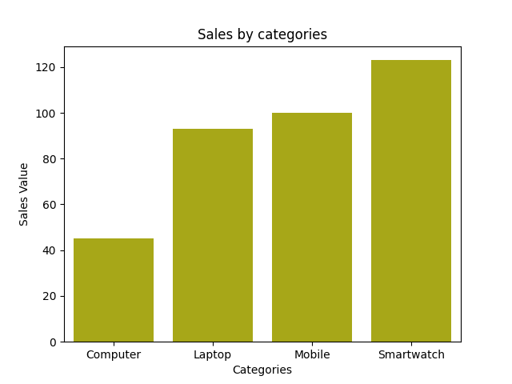

# 4.Generate a dataset with categories and numerical values. Visualize the distribution of a numerical variable across different categories.

import numpy as np

import pandas as pd

import seaborn as sns

data = {

    'Categories' : ['DSA','ML','Python','ML','DSA','ML','Python'],

    'Values' : np.random.randint(1,100,7)

}

df = pd.DataFrame(data)

sns.catplot(x=df['Categories'],y=df['Values'],kind='violin')

plt.title('Categories wise value')

plt.show()

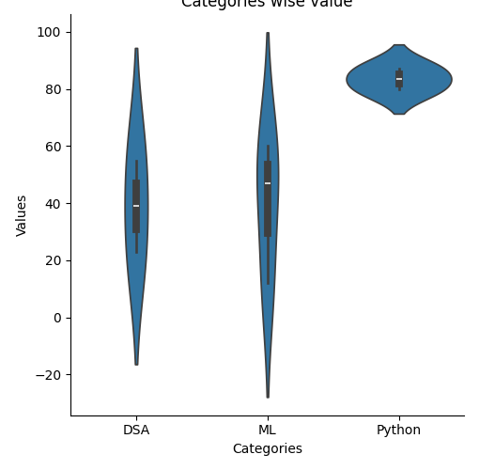

# 5. Generate a synthetic dataset with correlated features. Visualize the correlation matrix of a dataset using a heatmap.

import seaborn as sns

sns.get_dataset_names()

 df = sns.load_dataset('titanic')

df.head()

df =df[['survived','age','fare','pclass']]

df.corr()

sns.heatmap(df.corr(),cmap='coolwarm',annot=True)

plt.show()

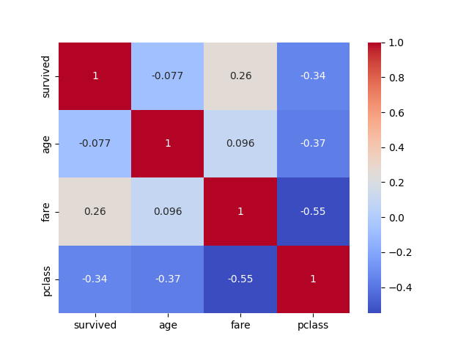

# **PLOTLY ASSIGNMENT:**

# Using the given dataset, to generate a 3D scatter plot to visualize the distribution of data points in a three dimensional space. np.random.seed(30)data = { 'X': np.random.uniform(-10, 10, 300), 'Y': np.random.uniform(-10, 10, 300),'Z': np.random.uniform(-10, 10, 300)} df = pd.DataFrame(data).

import pandas as pd

import numpy as np

import plotly.graph_objects as go

import plotly.express as px

fig = go.Figure()

fig =px.scatter_3d(x=df['X'],y=df['Y'],z=df['Z'])

fig.show()

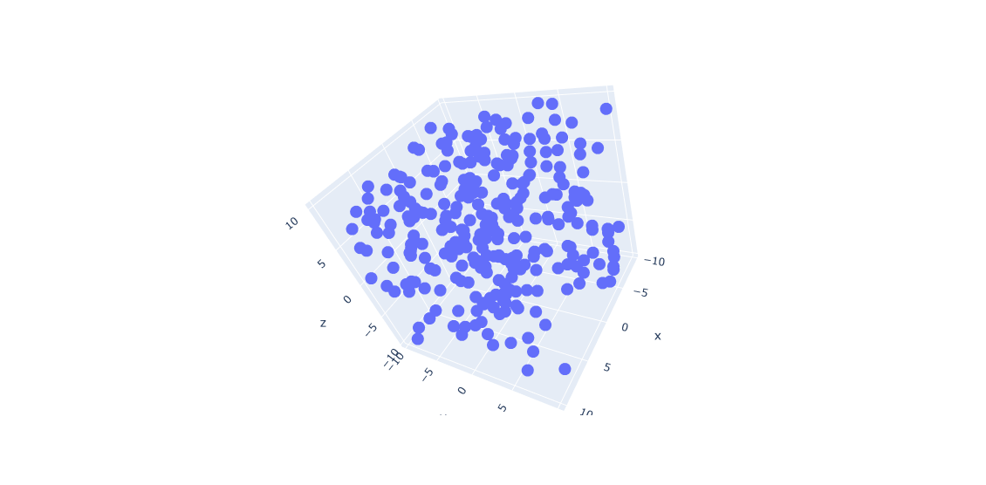

# Using the Student Grades, create a violin plot to display the distribution of scores across different grade categories. np.random.seed(15) data = { 'Grade': np.random.choice(['A', 'B', 'C', 'D', 'F'], 200), 'Score': np.random.randint(50, 100, 200) } df = pd.DataFrame(data ).

import numpy as np

import pandas as pd

import plotly.express as px

np.random.seed(15)

# Create a DataFrame with random grades and scores

data = {

    'Grade': np.random.choice(['A', 'B', 'C', 'D', 'F'], 200),

    'Score': np.random.randint(50, 100, 200)

}

df = pd.DataFrame(data)

# Create a violin plot using Plotly Express

fig = px.violin(df, x='Grade', y='Score', title='Distribution of Scores by Grade')

# Show the plot

fig.show()

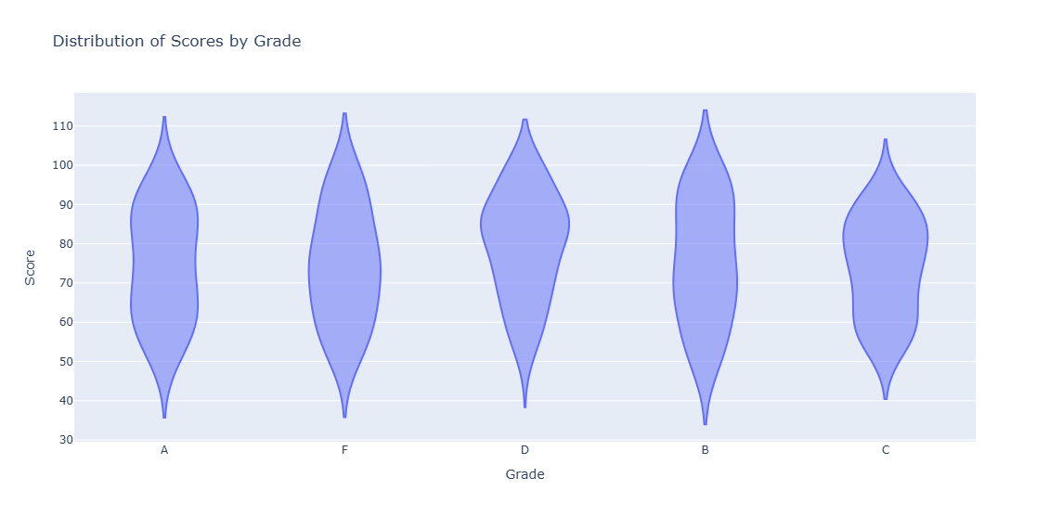

# Using the sales data, generate a heatmap to visualize the variation in sales across different months and days. np.random.seed(20) data = { 'Month': np.random.choice(['Jan', 'Feb', 'Mar', 'Apr', 'May'], 100), 'Day': np.random.choice(range(1, 31), 100), 'Sales': np.random.randint(1000, 5000, 100) } df = pd.DataFrame(data).

 np.random.seed(20)

 data = {

 'Month': np.random.choice(['Jan', 'Feb', 'Mar', 'Apr', 'May'], 100),

 'Day': np.random.choice(range(1, 31), 100),

 'Sales': np.random.randint(1000, 5000, 100)

 }

df = pd.DataFrame(data)

import plotly.graph_objects as go

import plotly.express as px

import pandas as pd

fig = px.density_heatmap(df,x='Month',y='Day',z='Sales',title='Heat map char of data',)

fig.show()

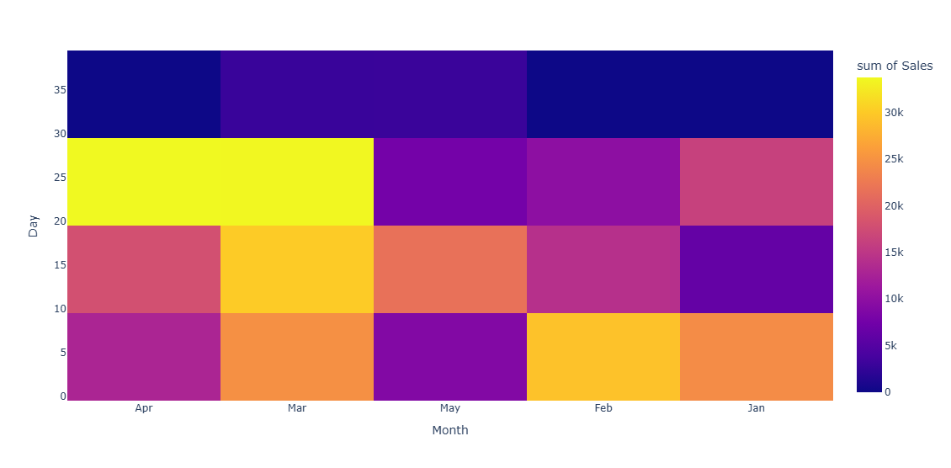

# 4. Using the given x and y data, generate a 3D surface plot to visualize the function x = np.linspace(-5, 5, 100) y = np.linspace(-5, 5, 100) x, y = np.meshgrid(x, y) z = np.sin(np.sqrt(x**2 + y**2)) data = { 'X': x.flatten(), 'Y': y.flatten(), 'Z': z.flatten() } df = pd.DataFrame(data).

df = pd.DataFrame(data)

import numpy as np

import plotly.graph_objects as go

# Generate the data

x = np.linspace(-5, 5, 100)

y = np.linspace(-5, 5, 100)

x, y = np.meshgrid(x, y)

z = np.sin(np.sqrt(x**2 + y**2))

# Create a 3D surface plot

fig = go.Figure(data=[go.Surface(x=x, y=y, z=z)])

# Set the title and axis labels

fig.update_layout(title='3D Surface Plot', xaxis_title='X', yaxis_title='Y', zaxis_title='Z')

# Show the plot

fig.show()

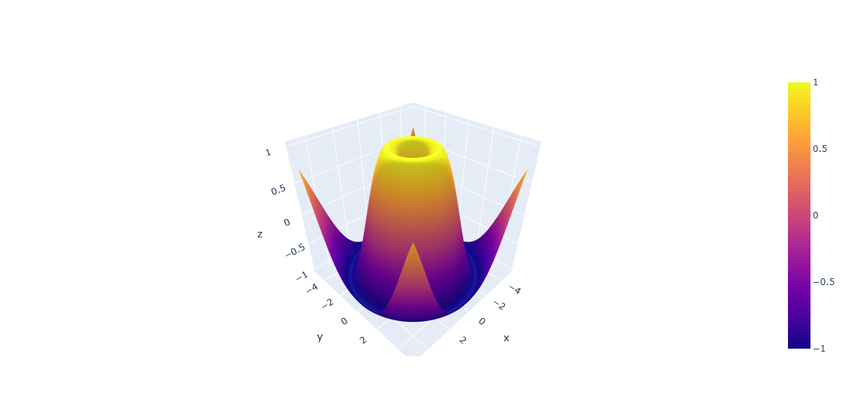

# Using the given dataset, create a bubble chart to represent each country's population (y-axis), GDP (x axis), and bubble size proportional to the population. np.random.seed(25) data = { 'Country': ['USA', 'Canada', 'UK', 'Germany', 'France'], 'Population': np.random.randint(100, 1000, 5), 'GDP': np.random.randint(500, 2000, 5) } df = pd.DataFrame(data).

import numpy as np

import pandas as pd

import plotly.express as px

np.random.seed(25)

# Create a DataFrame with random data

data = {

    'Country': ['USA', 'Canada', 'UK', 'Germany', 'France'],

    'Population': np.random.randint(100, 1000, 5),

    'GDP': np.random.randint(500, 2000, 5)

}

df = pd.DataFrame(data)

# Create a bubble chart using Plotly

fig = px.scatter(df, x='GDP', y='Population', size='Population', color='Country',

                 title='Bubble Chart of Population and GDP')

# Show the bubble chart

fig.show()

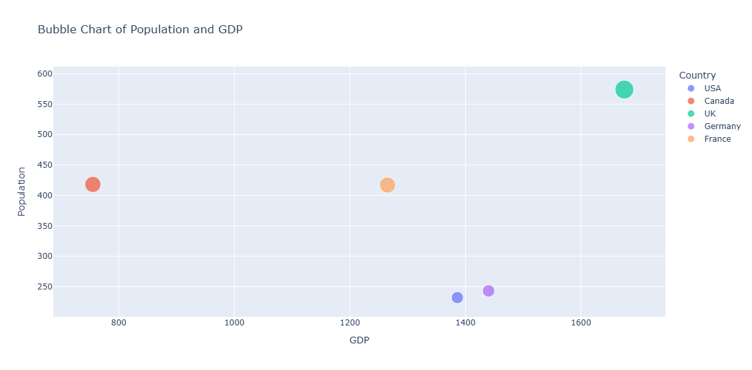

# **BOKEH ASSIGNMENT:**

# 1.Create a Bokeh plot displaying a sine wave. Set x-values from 0 to 10 and y-values as the sine of x.

# Import necessary modules

import numpy as np

import bokeh.plotting as bp

from bokeh.io import output_file, show

# Generate x and y values for the sine wave

x = np.linspace(0, 10, 1000) # 1000 points between 0 and 10

y = np.sin(x)

# Specify the output file to save the plot

output_file("sine_wave_plot.html")

# Create a Bokeh figure

fig = bp.figure(title="Sine Wave", x_axis_label='X Axis', y_axis_label='Y Axis')

# Add a line plot to the figure

fig.line(x, y, line_width=2, color="blue")

# Show the plot

show(fig)

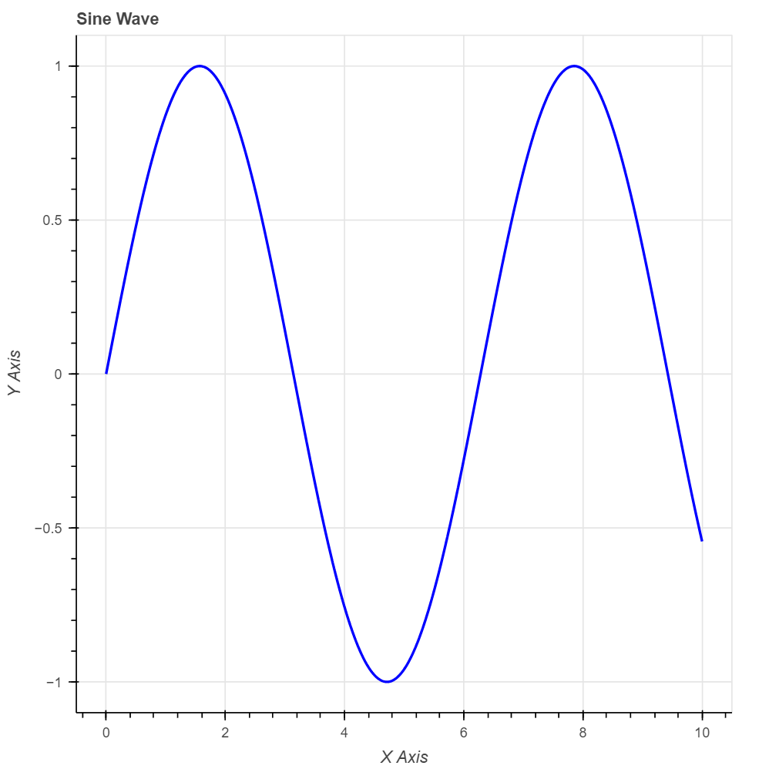

# 2.Create a Bokeh scatter plot using randomly generated x and y values. Use different sizes and colors for the markers based on the 'sizes' and 'colors' columns.

from bokeh.plotting import figure, show

from bokeh.io import output_notebook

import numpy as np

import random

# Prepare output to be displayed in the notebook

output_notebook()

# Generate random data for x and y values

x = np.random.rand(50) * 100

y = np.random.rand(50) * 100

# Generate random sizes and colors

sizes = np.random.rand(50) * 50 + 10 # sizes between 10 and 60

colors = ["#" + ''.join([random.choice('0123456789ABCDEF') for _ in range(6)]) for _ in range(50)]

# Create a scatter plot

p = figure(title="Bokeh Scatter Plot with Random Data", x_axis_label='X Axis', y_axis_label='Y Axis')

# Add scatter renderer

p.scatter(x, y, size=sizes, color=colors, fill_alpha=0.6)

# Show the plot

show(p)

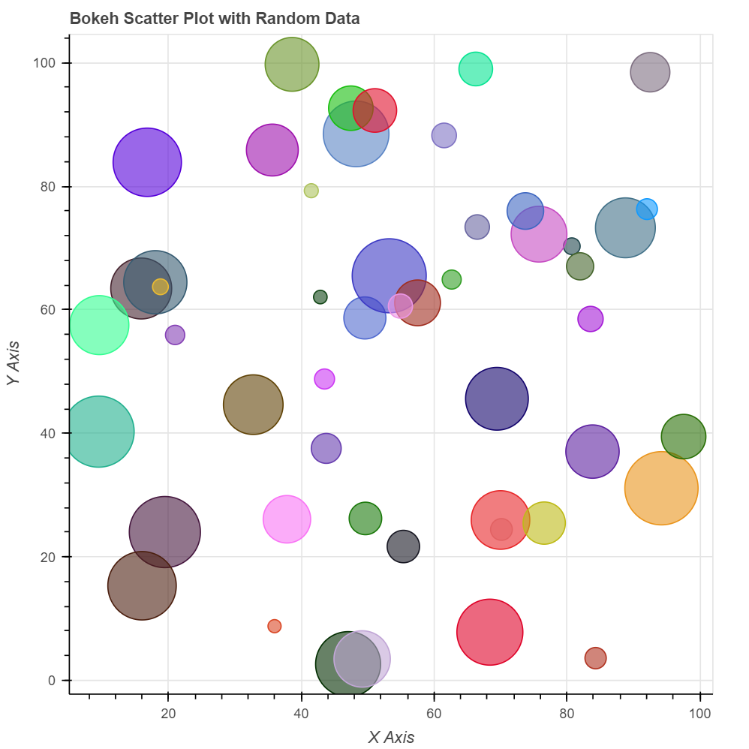

# Generate a Bokeh bar chart representing the counts of different fruits using the following dataset. fruits = ['Apples', 'Oranges', 'Bananas', 'Pears'] counts = [20, 25, 30, 35].

# Import necessary modules

from bokeh.plotting import figure, show

from bokeh.io import output_file

# Dataset

fruits = ['Apples', 'Oranges', 'Bananas', 'Pears']

counts = [20, 25, 30, 35]

# Specify the output file to save the plot

output_file("fruit_counts_bar_chart.html")

# Create a Bokeh figure

p = figure(x_range=fruits, title="Fruit Counts", x_axis_label='Fruits', y_axis_label='Counts',

toolbar_location=None, tools="")

# Add a bar renderer

p.vbar(x=fruits, top=counts, width=0.5, color="green")

# Customize appearance

p.y_range.start = 0

p.xgrid.grid_line_color = None

p.ygrid.grid_line_color = None

# Show the plot

show(p)

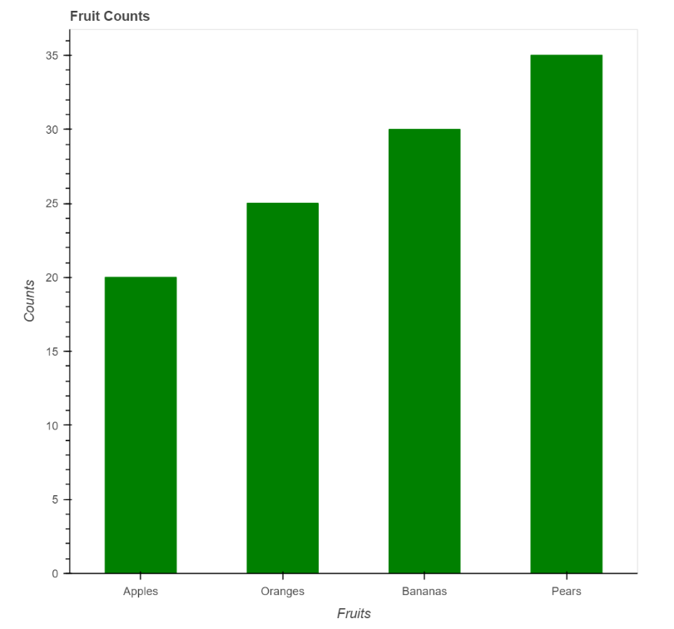

# Create a Bokeh histogram to visualize the distribution of the given data. data_hist = np.random.randn(1000) hist, edges = np.histogram(data_hist, bins=30).

import numpy as np

from bokeh.plotting import figure, show

from bokeh.io import output_file

# Generate random data for the histogram

data_hist = np.random.randn(1000)

# Compute the histogram

hist, edges = np.histogram(data_hist, bins=30)

# Specify the output file to save the plot

output_file("histogram_plot.html")

# Create a Bokeh figure

p = figure(title="Histogram of Data", x_axis_label='Value', y_axis_label='Frequency')

# Add a quad renderer for the histogram

p.quad(top=hist, bottom=0, left=edges[:-1], right=edges[1:], fill_color="blue", line_color="white", alpha=0.7)

# Show the plot

show(p)

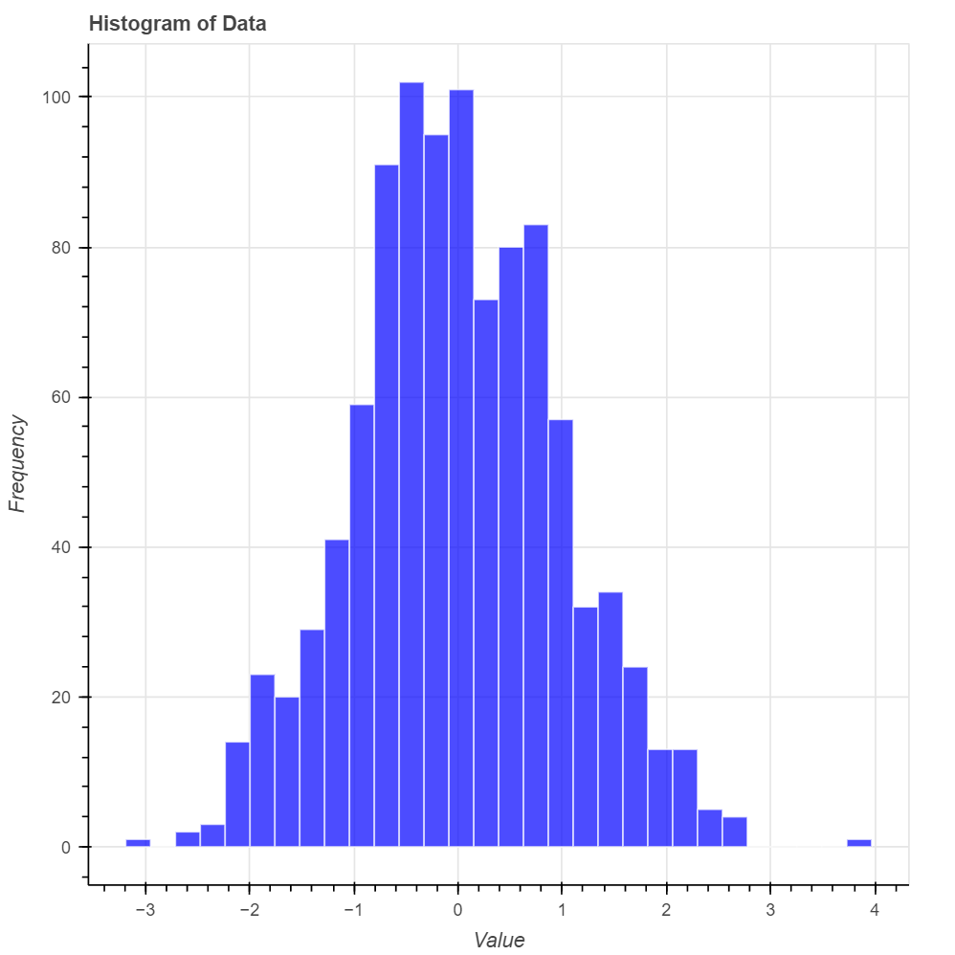

# Create a Bokeh heatmap using the provided dataset. data_heatmap = np.random.rand(10, 10) x = np.linspace(0, 1, 10) y = np.linspace(0, 1, 10) xx, yy = np.meshgrid(x, y).

import numpy as np

from bokeh.plotting import figure, show

from bokeh.io import output_file

# Provided data for the heatmap

data_heatmap = np.random.rand(10, 10)

x = np.linspace(0, 1, 10)

y = np.linspace(0, 1, 10)

xx, yy = np.meshgrid(x, y)

# Specify the output file to save the plot

output_file("heatmap_plot.html")

# Create a Bokeh figure

p = figure(title="Heatmap", x_axis_label='X Axis', y_axis_label='Y Axis',

x_range=(0, 1), y_range=(0, 1))

# Add image glyph for heatmap

# Bokeh expects a list of 2D arrays for the image parameter

p.image(image=[data_heatmap], x=0, y=0, dw=1, dh=1, palette="Viridis256")

# Show the plot

show(p)

